Tyler Dumont marks her triumphant return with stunning and soulful R&B single and video ‘The Letter’

LISTEN HERE // WATCH HERE

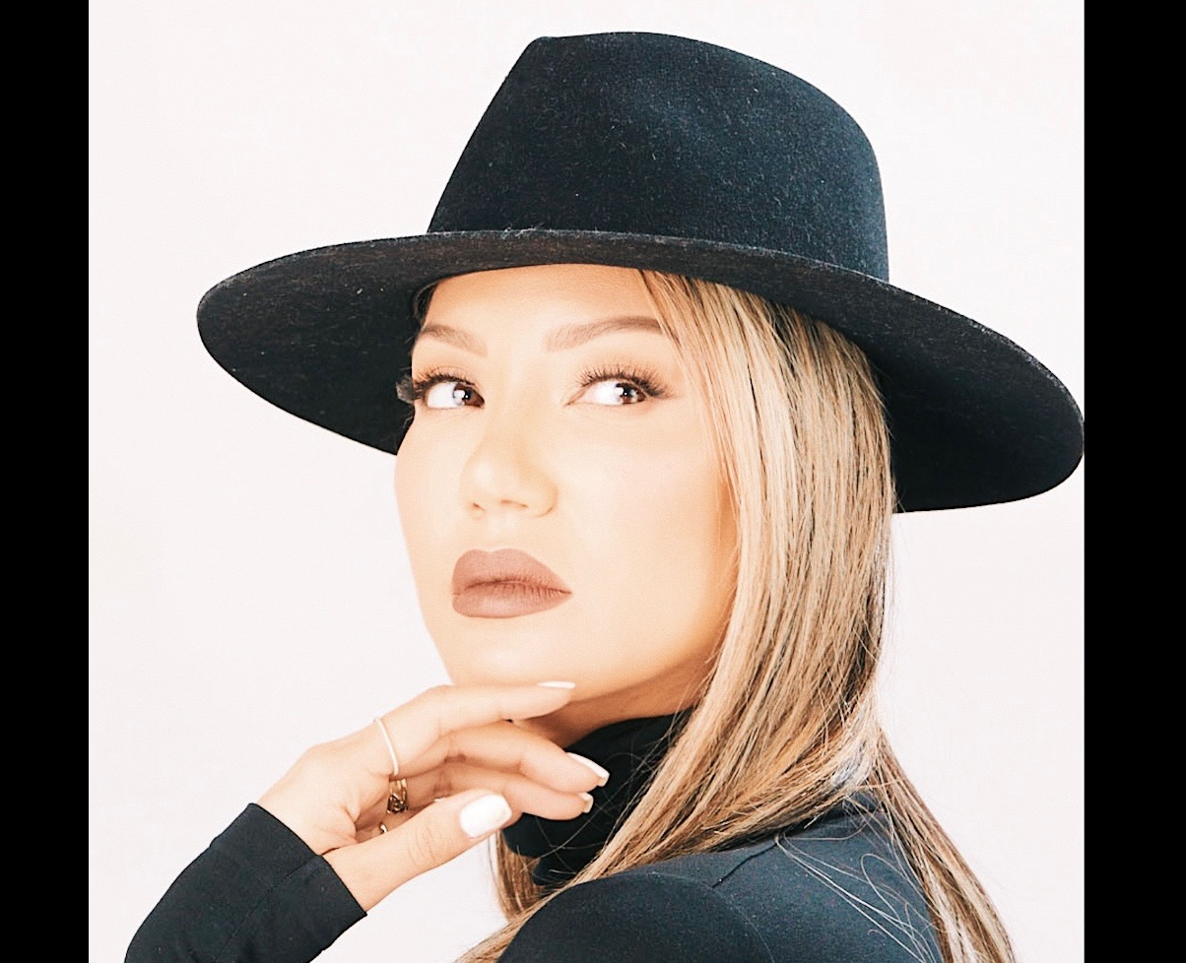
DOWNLOAD PRESS PICS

RELEASE INFO

DEBUT SINGLE ‘THE LETTER’ OUT AUGUST 8th
After a five-year hiatus, rising R&B sensation Tyler Dumont returns with her highly anticipated single and video for, ‘The Letter’, a stunning display of vulnerability, empowerment, and timeless artistry. Known for her unique fusion of contemporary R&B, neo-soul, and pop, Tyler has crafted a sound that bridges the golden warmth of ’90s R&B with the sleek polish of modern production.
Born in Miami and raised in New York, Tyler draws on her Caribbean heritage and the influence of icons like Sade, Lauryn Hill, and Michael Jackson, infusing every lyric with authenticity and depth. ‘The Letter’ showcases her sultry, emotionally rich vocals, gliding effortlessly over a soft yet brooding instrumental that feels both nostalgic and refreshingly current.

STREAM MORE HERE

Built on a delicate balance of silky keys, atmospheric synth layers, and a slow-burning beat, the track’s production perfectly mirrors the emotions at its core. The arrangement swells and retracts like a tide, allowing Tyler’s melodic hooks and tender ad-libs to float freely in the mix. With subtle nods to the early 2000s R&B era but a distinctly modern sonic palette, ‘The Letter’ delivers a listening experience that feels intimate, cinematic, and effortlessly cool.
She shares “I’m incredibly excited to share my new single, ‘The Letter’. This song holds deep meaning for me, not only as an artist, but on a very personal level. After stepping away from music for five years, returning with something this raw and honest has been both vulnerable and empowering. I truly hope it resonates with listeners, and that my fans feel the heart, truth, and emotion I poured into every lyric.”
From its melancholic undertones to its infectious hooks, ‘The Letter’ is a masterclass in contemporary R&B storytelling, a track that lingers long after the last note fades. As Tyler Dumont continues to carve her own path in the music industry, this release is proof that she’s leading the way in R&B’s new wave and resurgence.
SOCIALS

https://www.instagram.com/tylerdumontmusic/?hl=en
https://www.facebook.com/thetylerdumont

